Contents
Introduction 2
Background 2
Product description 2
Reserving issues in level premium term 3
Representative Scenarios Method Demonstration 5
Steps 1, 2 and 3 5
Step 4 7
Step 5 7
Step 6 7
Analysis 8
Comparison of RSM to Other Methods 8
Margins 9
Risk breakdown over time 9
Aggregate margins over time 10
Aggregate margins compared to full stochastic modeling 13
Dependence of reserves on pricing level 16
Appendix 1: Product description and assumptions 18
Appendix 2: Treatment of net premium reserves 20
Appendix 3: Generation of full stochastic scenarios 21
Appendix 4: Results of modeling each issue age / level term period on its own 22
Age 35, 10 year level term 23
Age 35, 20 year level term 24
Age 35, 30 year level term 25
Age 55, 10 year level term 26
Age 55, 20 year level term 27

Prepared by Stephen J. Strommen FSA, CERA, MAAA
April 11, 2015

Introduction

This paper is an extension of the introductory overview document titled “Representative Scenarios Method”. In order to appreciate the case study presented in this report, the reader is advised to gain a fundamental level of understanding of the Representative Scenarios Method (RSM), in particular, the six steps involved in deriving a reserve using the RSM. These six steps are summarized below, and referred to throughout this narrative.
Step 1: Identify blocks of business with substantially similar risks. Identify the block’s key risk drivers (KRDs), which are those assumptions whose variability can significantly affect the cost of fulfilling the contract.
Step 2: Determine the distribution of assumption values for each KRD.
Step 3: Generate scenarios for each KRD within its distribution. The five scenarios used in this study are the median, +/-1 standard deviation and +/- 3 standard deviations. This is consistent with the overview document. The total number of scenarios necessary for the determination of the RSM reserve is equal to 1 + (number of KRDs)*(number of scenarios per KRD – 1)
Step 4: Project asset and liability cash flows. In this step, each scenario is assigned a scenario reserve. The scenario reserve is the level of starting assets required to satisfy all liability cash flows until the contracts expire.
Step 5: Calculate a central estimate as a weighted average of the scenario reserves. Within each KRD, the scenarios are assigned probability weights. Each KRD is also assigned a weight. Combining the scenario reserves using these weights determines the central estimate of the reserve prior to margins.
Step 6: Add an aggregate margin to the reserve. Two alternate approaches are proposed for calculating the aggregate margin – the cost of capital approach and the percentile approach. The results of both are presented and compared in this study.

Background

Product description

Level premium term life insurance provides a fixed benefit amount upon death at very low cost. Premiums are level and as low as possible for an initial term which may be 10, 20, or 30 years. After the initial term, premiums are much higher and increase every year. Coverage terminates at age 95.
Most policy owners are expected to terminate their policy at the end of the initial level premium term, so the insurer expects the mortality experience on those that remain to be much poorer, and sets the premiums much higher after the initial level term in anticipation of an elevated mortality rate.
Some level premium term life insurance contracts include additional benefits or options such as return of premium on death, conversion to permanent life insurance, extra benefits on accidental death, and others. In the interest of simplicity, no such additional benefits are attached to the policies used for this case study.
Five variations of level premium term are studied. These are:
10 year term, issue age 35 10 year term, issue age 55
20 year term, issue age 35 20 year term, issue age 55
30 year term, issue age 35
All contracts are issued to males, and the amount of insurance is $500,000 per contract. Full details of assumed experience and other pricing assumptions are contained in the appendix.

Reserving issues in level premium term

Insurers have long argued that required statutory reserves for level premium term insurance are higher than necessary. The following issues form parts of that argument.
- The mortality rates used to compute statutory reserves are well above the average experience by the industry partly because the pace of valuation table development lags industry experience to a great degree. Careful underwriting leads to business with substantially lower mortality rates, but reserves are not allowed to reflect that level of mortality.
- There is an ongoing trend of improvement in mortality experience over time, and this is expected to continue. However, mortality rates used to compute reserves are not allowed to reflect this expected trend.
- The costs of distribution and underwriting of new contracts substantially exceed the first year premium. These costs are recovered in future renewal premiums. However, the expense allowance in statutory reserves is much smaller than actual expenses, and this tends to overstate the required reserve.
- Statutory reserves are not allowed to be negative. However, the pattern of high initial expenses followed by expense recovery in renewal premiums suggests that reserves in early durations should be negative because the expense recovery built into renewal premiums represents an asset.
The development of principle-based reserves and VM-20 has addressed these concerns to some degree. However, industry is still concerned that reserves under VM-20 are larger than needed.
One way to understand the industry’s view is to compare statutory net premium reserves with “natural” reserves. The concept of “natural” reserves was introduced decades ago, and the calculation of a natural reserve is conceptually similar to a net premium reserve. In both cases, the reserve is the present value of future net cash flows, and the amount of premium included in the net cash flows is determined so that just before the contract is issued the present value of premiums equals the present value of benefits. This equality is based on the concept of “no gain or loss at issue”.
“Natural” reserves are different from statutory net premium reserves in the following respects:
 | Statutory net premium reserve | Natural reserve
Premiums included in cash flows | Statutory net premiums | Level % of gross premiums
Assumptions | Prescribed interest, mortality and expense allowance, zero lapses | Anticipated interest, mortality, lapse, and expenses
Margin | Limited expense allowance, spread between prescribed and actual experience mortality and interest | Present value of a level % of remaining gross premiums, calibrated to prevent gain at issue

If “natural” reserves were used in financial statements, profits would be expected to emerge as a level percentage of gross premiums in each period. Since profits represent the release of reserve margins, this means that the reserve margin is always the present value of a percentage of future gross premiums.
There are no regulatory controls over the gross premiums charged by life insurers. Regulators have not approved use of “natural” reserves partly because there is no assurance that the margin (% of future gross premium) is sufficient. However, when products are priced so that reasonable profits are anticipated, those margins are more likely to be sufficient, and that is the situation in this study.
With that in mind, the chart below illustrates the difference between statutory net premium reserves and “natural” reserves over time for a block of 20-year level term business where all contracts are issued on the same date. The difference is striking when presented in this way, and it well illustrates why industry views current statutory reserves as larger than necessary. In the chart, the CRVM method is that method described by the Valuation of Life Insurance Policies Model Regulation as it applies to the product used in this case study.
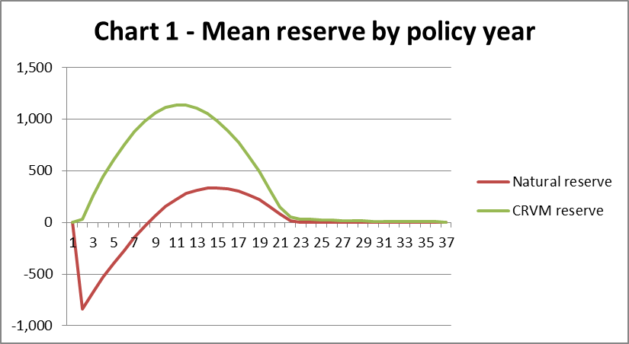
One way to think of the Representative Scenarios Method is as a means of calculating a “natural” reserve, but with a margin defined by regulators as sufficient. Therefore we can expect reserves under RSM to track over time like “natural” reserves. The central estimate is based on anticipated experience in both cases, but the reserve itself will be higher or lower depending whether the RSM margin is higher or lower.

Representative Scenarios Method Demonstration

Steps 1, 2 and 3

The following paragraphs describe the six KRDs identified for the level premium term product (i.e. Step 1); the distribution of each KRD’s values (Step 2); and the 5 scenarios within each KRD distribution (Step 3).
The choices made for this study are those of the author and are based on a combination of professional judgment and statistical technique.
- Mortality statistical fluctuation. To simulate this risk, mortality rates for each year are multiplied by a value that indicates the level of experience in that year relative to expectations. When the value is 1.0, mortality is as expected. The distribution of the multiplier for any single year is defined by this table, which is based on statistical fluctuation for a block of business that expects about 100 death claims per year.
Percentile | Multiplier
99% | 1.34
84% | 1.11
50% (anticipated) | 1.0
16% | 0.90
01% | 0.73

- Mortality improvement trend. To simulate this risk, mortality improvement scale G was multiplied by a value that indicates the level of improvement relative to expectations. The distribution of the multiplier is defined by the table below. Values in this table are highly subjective because the distribution of future mortality improvement is largely unknown, though the level of historical improvement has been studied for many years. Regulators may wish to specify the values that should be used. Note that the value currently used for regulatory purposes is zero, which this table suggests is at the low end of the distribution. For this risk driver, the same multiplier is used for every time period in a scenario.
Percentile | Multiplier
99% | 1.25
84% | 1.15
50% (anticipated) | 1.0
16% | 0.7
01% | 0.0

- Lapse rates. To simulate this risk, lapse rates for each year are adjusted by adding a value that indicates the level of experience in that year relative to expectations. When the value is 0.0, lapse rates are as expected. The distribution of the add-on for any single year is defined by this table:
Percentile | Add-on
99% | 0.05
84% | 0.02
50% (anticipated) | 0.0
16% | -0.02
01% | -0.05

- Interest rates. To simulate this risk, scenarios are defined by the series of “random” shocks used in the VM-20 interest rate scenario generator. The development of the series of shocks is described elsewhere, but uses the same methodology as was used for the scenarios in the VM-20 stochastic exclusion test.

- Default costs. To simulate this risk, default costs for each year are adjusted up or down by an additive amount. The additive amount is a multiple of the default cost margin specified in VM-20. The multiples used are defined by the table below. Note that this risk is asymmetric because default costs can increase much more than they can decrease. For this risk driver, the same multiplier is used in every time period in a scenario.
Percentile | Add-on
99% | 3.0
84% | 1.0
50% (anticipated) | 0.0
16% | -0.5
01% | -1.0

- Expenses. To simulate this risk, home office expense unit costs for each year are multiplied by a value that indicates the level of expense for that year relative to expectations. When the value is 1.0, expenses are as expected. The distribution of the multiplier is defined by this table:
Percentile | Multiplier
99% | 1.1
84% | 1.02
50% (anticipated) | 1.0
16% | 0.98
01% | 0.90

Step 4
An actuarial model depicting the level term product portfolio was run over the 25 scenarios described above (anticipated, plus 6 KRDs over 4 non-baseline scenarios). Each of the 25 runs results in one scenario reserve.

Step 5
Probability weights were assigned to each of the 5 scenarios within each KRD. These weights are prescribed as part of RSM. Then each KRD was assigned a weight based on the range of scenario reserves for that KRD, so that a KRD with a wider range of scenario reserves gets greater weight. The combined result provides the weighted average scenario reserve that is used as a central estimate before adding margins.

Step 6
Margins were added. For this study two different approaches were used to calculate an aggregate margin – the cost of capital approach and the percentile approach. Further discussion of these approaches and the results is included in the next section.

Analysis

Comparison of RSM to Other Methods

To get a general understanding of the level of reserves under RSM for level term, we first study a simulated block of such business. The simulated block of business includes business issued over the years 2010-2014, and our initial valuation is at the end of 2014. Equal amounts of premium were sold each month under each of the cells we study. There are five cells: at issue age 35 there are 10-year, 20-year and 30-year level term, and at issue age 55 there are 10-year and 20-year level term. For purposes of projecting results over time, the interest rate scenario is flat with 20-year Treasuries at 4.0%.

The chart below shows the level of reserves over time for the block of level term business in this case study.
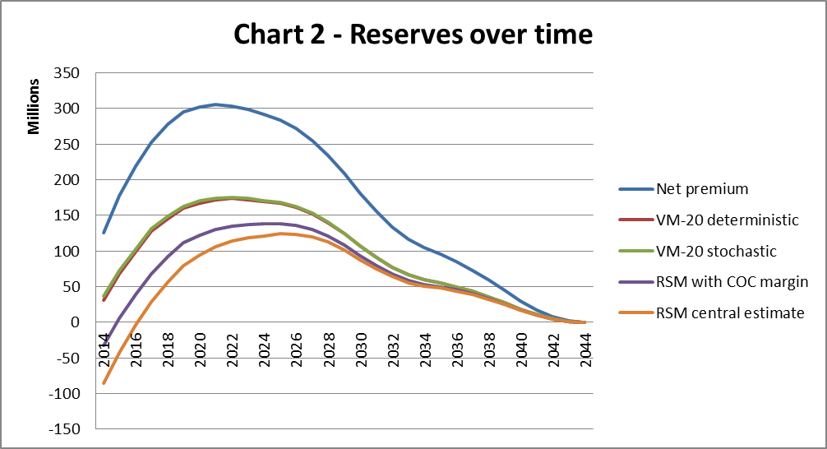
The difference between the reserves shown above can be roughly attributed to adding various margins as follows, starting from the smallest reserve shown:
- The RSM central estimate includes no margin, so it too small for a reserve.
- The RSM with cost-of-capital (COC) margin includes what is arguably a sufficient aggregate margin. As will be discussed later, this margin is larger than a stochastic CTE70 reserve would be for most of the time period shown.
- The VM-20 reserves add additional margin mainly because future mortality improvement cannot be reflected. The stochastic and deterministic reserves are very close together.
- The Net premium reserve adds further additional margin because the initial expense allowance is much smaller than actual expenses. As noted above, this reserve reflects the method required by the Valuation of Life Insurance Policies Model Regulation for term insurance (Xxx). The product as valued under Xxx is assumed to be void of premium deficiency reserves.

Margins

The various scenario reserves produced using the RSM provide substantial information about the size of various risks, and that information can be used to calculate an aggregate margin under either the cost of capital approach or the percentile (CTE) approach. The first subsection below illustrates the breakdown of risks over time, and the second shows the results of applying that information to calculate an aggregate margin under either method being considered.

Risk breakdown over time

The range of scenario reserves for each risk driver (i.e. the minimum and maximum produced by the five scenarios within each KRD) provides information about the size of the risk posed by that risk driver. The excess of the highest scenario reserve over the central estimate represents the total loss relative to expectations that could arise from that risk driver in the most adverse representative scenario, and is referred to as the risk amount. That figure can be used to measure the size of that risk in the context of total risk.
The chart below illustrates the size of each risk in the sample block of business over time.
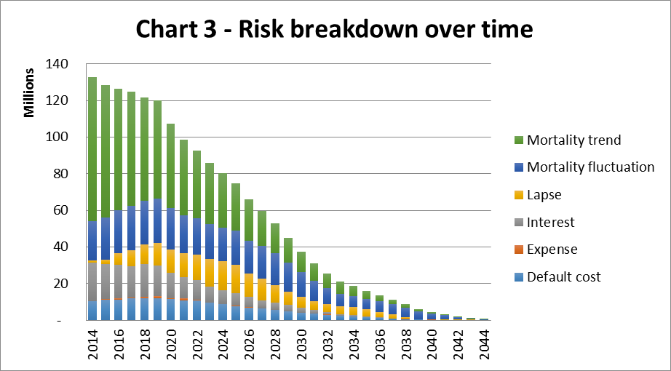
The following observations arise from the breakdown of risks over time:
- The largest risk is the mortality trend, at over $70 million initially. As time passes this risk declines rapidly.
- The second largest risk is mortality fluctuation. Since claims are heaviest in later years, this risk remains significant as long as business remains on the books.
- The lapse risk is surprisingly small in 2014-2015. This is because the direction of this risk changes over time. Before 2015, high lapse rates are adverse due to the loss of renewal premiums and the expense recovery that they provide. After 2015, high lapse rates are favorable due to the elimination of future claims liabilities. In 2014-2015 these risks largely offset so the total risk due to lapse rates is minimal at that time.
- Default cost risk is comparable in size to interest rate risk. This is dependent, of course, on the assumed quality of the investment portfolio, which in this example is on the low end of investment grade.
- Expense risk is not material. Therefore it would not need to be included as a Key Risk Driver.

Aggregate margins over time

The information provided by the RSM concerning the size of each risk can be applied to calculate an aggregate margin under either of two approaches – the cost of capital approach and the percentile or CTE approach.
The cost of capital approach is much like the “transfer value” approach to Margin over Current Estimate that is discussed in international capital deliberations. Under the cost of capital approach, one calculates the margin in four steps:
- Aggregate the total risk amounts together to get a total aggregate risk amount or initial capital requirement. This aggregation can be done in the same manner that the RBC formula aggregates C-1, C-2, C-3, and C-4 risks, using a square-root of sum of squares formula.
- Project the initial capital amount forward in time in proportion to the remaining present value of benefits at any point in time, based on the anticipated experience scenario.
- Multiply the projected capital amounts by a cost of capital rate such as 6% in order to get a projected cost of capital for each future year. This 6% factor could be adjusted by regulators to calibrate the margin to a desired level.
- The aggregate margin is the present value of the projected future cost of capital amounts, using discount rates from the anticipated experience scenario.
Under the percentile approach, one uses information from different scenarios. Rather than the most adverse scenarios for each risk driver (which define the “risk amount”), one uses the scenario reserves at the 1-standard deviation level. For each risk, a “margin risk amount” is the excess of the largest of the 1-standard deviation scenario reserves (either the plus 1 or the minus 1) over the central estimate. Given these “margin risk amounts” the calculation of the aggregate margin can be a single step:
- Aggregate the “margin risk amounts” together to get a total aggregate margin. This aggregation can be done in the same manner that the RBC formula aggregates C-1, C-2, C-3, and C-4 risks, using a square-root of sum of squares formula.
Of course this calculation reflects a percentile level corresponding to 1-standard deviation rather than a CTE. If one wishes to apply the theory behind the CTE, one could modify the estimate of the “margin risk amount” for each risk driver so that it is based on a blend of scenario amounts at different levels of severity rather than just one level of severity. The scenario amounts at other levels of severity could be interpolated or estimated in some other fashion that doesn’t require running more scenarios.
The chart below compares the aggregate margins under the two methods over time. A log scale is used for the vertical axis so that proportional differences remain visible even as both margins get much smaller in dollars as the business runs off the books.
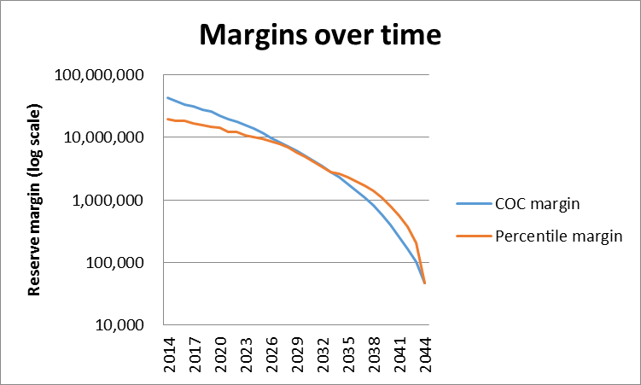
The main difference between these two margin methodologies is apparent from this graph. The COC margin tends to be larger when the business still has a long period to run. However, the COC margin is released faster, and becomes lower than the percentile margin as the business approaches expiry.
The difference arises because the COC margin is the present value of an annuity where each payment is for the cost of capital. The larger the number of payments remaining, the larger is the present value and the larger the COC margin. In contrast, the percentile margin is based on the stochastic distribution at a snapshot in time and is less dependent on the amount of time remaining.
The chart below provides another perspective – the margin as a percentage of the aggregate risk amount from the previous subsection.
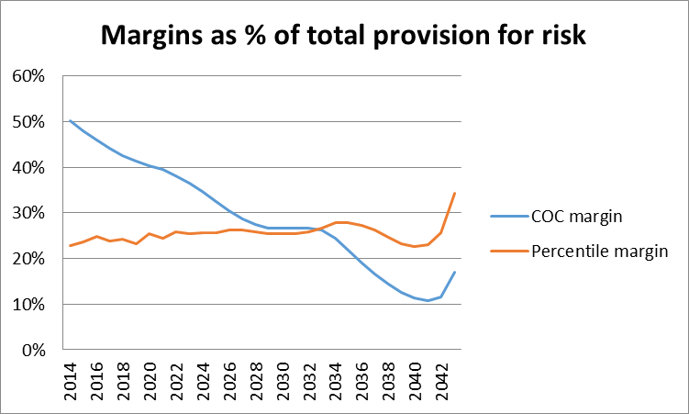
Several observations can be made concerning the chart above:
- Again we see that the COC margin starts higher (when the contracts still have decades to run) but runs off faster.
- The percentile margin remains roughly a level percent of the total provision for risk, as one would expect. If the total provision for risk is about 3 standard deviations and the margin is about 1 standard deviation, the margin would be about 33% of the total. In this case the risk distribution has a bit of a long tail so the percentile margin is less than 33% of the total with the tail. A slightly altered version that estimates the CTE instead of a percentile would likely be higher than shown.
- The odd behavior at the end of the chart is influenced by the transition to YRT premiums when the level period expires. Since 95% of the business is assumed to lapse before 2 years into the YRT period, the remaining reserve is very small. But the margin in that reserve proportionally resembles business which, on average, has several years before termination or expiry.
Before concluding that the COC margin is “too high” compared to the more traditional percentage margin, keep in mind the results shown in the first section. The reserve under RSM, including the COC margin, is still substantially smaller than under VM-20. This difference is largely due to allowing the assumption of mortality improvement in the central estimate under RSM. This assumption difference alone affects the reserve in 2014 by over $70 million.

Aggregate margins compared to full stochastic modeling

Some observers are skeptical that the small number of scenarios used in the RSM will provide a usable approximation to the results of full stochastic modeling. To study that issue, full stochastic valuations using 1000 scenarios were carried out at each valuation date. These stochastic scenarios treated every Key Risk Driver stochastically, not just investment returns.
The chart below shows the percentile level margin based on full stochastic modeling and compares that with the aggregate margin (percentile approach) estimated using RSM. Two different percentile levels are shown. Viewed this way, it appears that the estimates under RSM are in the ballpark and may be sufficiently accurate for reserving purposes. If RSM were to be adopted, it might enable the regulatory focus to turn to the assumptions in use and away from disagreements about reserving methodology.
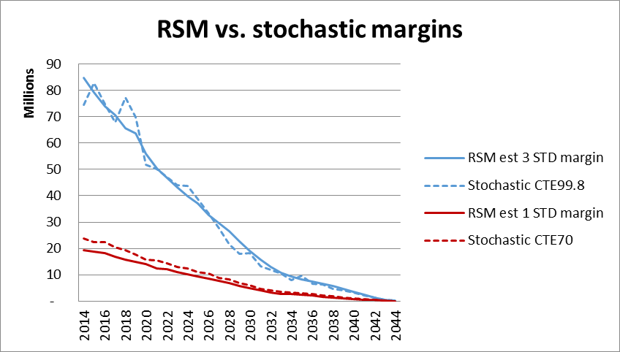

The chart below shows the percentile level in the full stochastic distribution that corresponds to the RSM reserve using both the percentile approach and the cost of capital approach for the aggregate margin.
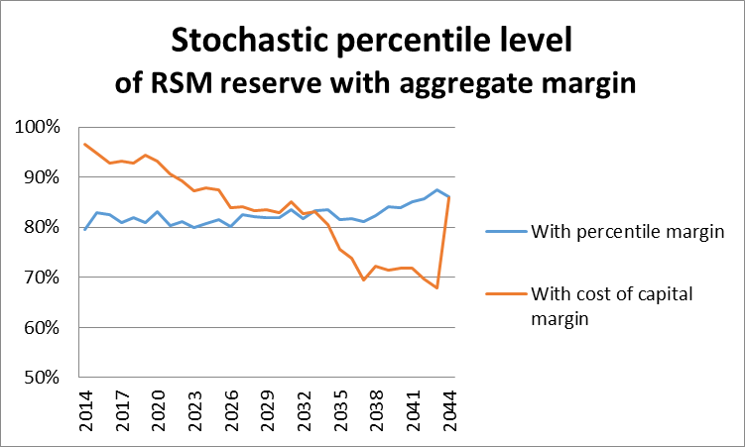
The following observations can be made based on the chart above:
- The RSM aggregate margin under the percentile approach remains very close to the intended percentile (around 84%).
- The aggregate margin under the COC approach starts higher and ends lower than that under the percentile approach. This is consistent with the charts shown earlier that compare the two methods.
- The uptick in the COC margin in the last year occurs because the last of the business reaches the end of its level term period and only YRT business remains. At this point the volume of business drops dramatically, as do the margins. But the business that remains has several years left before expiry, and the relationship between the levels of the two margins reflects that.
With the focus here on differences between various calculations of the margin, it is easy to lose sight of the big picture. The margins are a small part of the reserve, so even though margins are slightly different, the reserves under RSM and full stochastic approaches are very similar, as shown in the chart below:
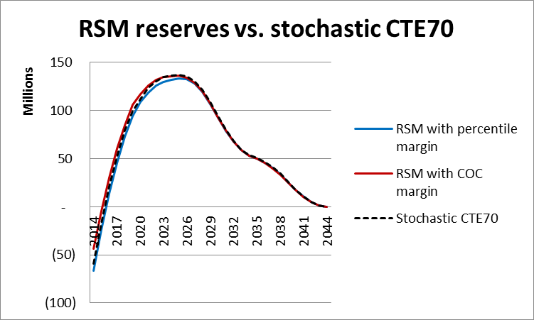
Another way to make the same point is to view the ratio of RSM reserves to stochastic reserves. This ratio stays close to 1 except when the reserve crosses zero (early years) or becomes tiny (last years).
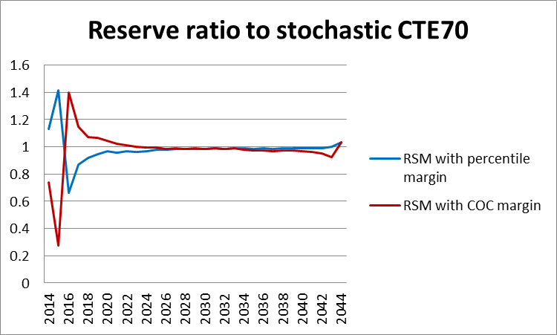

Dependence of reserves on pricing level

Since principle-based reserves reflect gross premiums, the level at which gross premiums are set affects the size of the reserve. The present value of future gross premiums is subtracted when calculating the reserve, so larger premiums lead to lower reserves.
For this study, a range of gross premium rates was determined based on a reasonable range of assumptions about future interest rates, mortality improvement, and profit targets. All of the results presented above have been based on the most competitive premium rates within that reasonable range. The chart below show how the RSM and VM-20 modeled reserves depend on the premium rates actually charged. The following considerations should be kept in mind to best understand this range of results.
- Competitive pressures will typically keep the premiums at the low end of the range used here, meaning that RSM reserves would typically be in the high end of the range shown.

- The fact that there is a range of reserve levels that depend on pricing conflicts with the concept that all insurers should hold the same reserve for the same product. If uniformity is desired, it could be enforced by defining some minimum reserve that all companies must hold, with RSM used to determine whether the minimum is adequate.

- The range of reserve levels illustrates how important the assumptions are. In this case, all the reserve levels are calculated using the same assumptions, just different gross premiums. However, it is likely that companies that set different gross premiums for the same product are actually using different assumptions. Therefore validation and control over assumption-setting is a vital part of any principle-based reserving process.
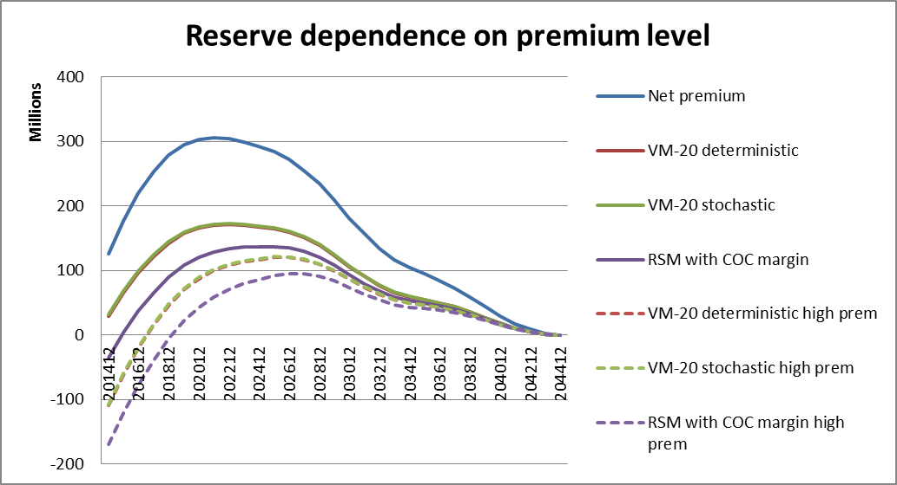
Observations:
- The net premium reserve does not depend on the level of the gross premium. However, higher gross premiums lead to lower reserves under the modeled reserve methodologies.
- The gross premium level can lead to very significant differences in modeled reserves for the same product between companies. The entire range of premium levels illustrated here is within reason under current market conditions. However, competitive pressures will tend to result in more business sold at lower premium levels which correspond to higher reserves.

Appendix 1: Product description and assumptions

Product features:
- Level premium period – model three different products
  - 10 year term
  - 20 year term
  - 30 year term
- No return of premium feature
- No conversion feature
- Renewable to age 95. High YRT premiums after the level premium period, with high shock lapse and increase in mortality rates

Issue ages:
- 35 (male only)
- 55 (male only)

Pricing assumptions:
- Mortality:
  - During level period: 60% of 2008 VBT Male Nonsmoker ALB Select with improvement from 2003 at scale G. Central year of issue assumed for pricing: 2012
  - After level period: 80% of 2001 CSO ALB Ultimate (gross premium will be 100%)
- Lapse rates:
  - 7% first year, 5% thereafter during level period
  - 90% shock lapse at end of level period, then 1yr at 50% with 20% annual lapse thereafter
- Interest rate earned: 4.00%
- Distribution costs:
  - 120% of premium first year, nothing thereafter
- Maintenance costs:
  - $100 issue cost + 10% of premium + $1 per unit
  - $50 annual maintenance cost
  - $120 per death claim
  - $20 per lapse
  - 2.5% premium tax
- Annual policy fee: $75, included in annual premium

Risk drivers for the Representative Scenarios Method:
- Mortality
  - Statistical uncertainty
  - Uncertain rate of improvement
- Lapses
  - Statistical uncertainty during level period
  - Shock lapse and lapse rates after level period
- Interest rates

Pricing (annual premiums for a $500,000 policy)
- A range of prices was determined using the following ranges of assumptions.
  - Investment return 4.0% to 6.0%
  - Mortality improvement 50% to 100% of scale G
  - Target return on investment (before tax) of 10% to 12%
- For purposes of the pricing ROI calculation, the total asset requirement each month was the sum of:
  - CRMV reserve using 60% of 2008 VBT mortality and 4% interest
  - Capital equal to 50% of expected claims plus 5% of the CRVM reserve
- For 10-year term the distribution cost was reduced to 60% of first year premium. Without a reduced distribution cost, the 10-year contract would almost always cost more per year than the 20-year contract so it would never be sold.
- The resulting high and low premiums for males are shown in the table below

Issue age | Level term | Annual premium range for $500,000
35 | 10 | $310 to $340
35 | 20 | $395 to $475
35 | 30 | $510 to $660
55 | 10 | $905 to $1020
55 | 20 | $1590 to $1970
55 | 30 | Not generally offered

Appendix 2: Treatment of net premium reserves

There has been a recent trend towards development of mortality tables that represent experience based on different levels of underwriting. The purpose is to allow reserves to be based on the table that best fits a company’s experience. In order to reflect that trend, the net premium reserves illustrated in this study are based directly on the company’s current experience, which is assumed to be 60% of the 2008 VBT.
To be specific, the net premium reserves shown in this report are based on:
- CRVM methodology consistent with Valuation of Life Insurance Policies Model Regulation for case study product
- 4.0% interest
- 60% of 2008 VBT male nonsmoker mortality (age last birthday)
- No deficiency reserves
In reality net premium reserves are required to be held at higher mortality, and sometimes deficiency reserves are required as well. As a result, current requirements generally lead to net premium reserves that are higher than shown.
Since the net premium reserves for this product are significantly higher than those under every other method under consideration, even when using the company’s actual current mortality, further study of the effect of more conservative assumptions on net premium reserves was not deemed worthwhile for this study.
For comparison purposes, the chart below compares the mortality rates used here with some standard tables.

Appendix 3: Generation of full stochastic scenarios

Stochastic scenarios used for regulatory reserving have in the past been stochastic only in their treatment of interest rates and investment returns. In order to compare results of the RSM with full stochastic modeling, it was necessary to treat all risk drivers stochastically. This appendix provides some details about how that was done.
The approach was to create a stochastic scenario generator for each risk driver. The generator had to have three characteristics:
- For each time increment, the generator starts by creating a random number between zero and 1, uniformly distributed.

- The generator uses a user-defined distribution for the risk driver. This distribution is specified by the user and specifies the generated output corresponding to any value of the random number. Since the random number ranges between zero and one it can be interpreted as a percentile value. The distribution is the definition of an S-curve. The generator simply looks up the value on the S-curve corresponding to the percentile level. The distribution (S-curve) can have any form; the only requirement is that it can map a random number between zero and 1 into an appropriate value for the risk driver.

- The time period to which the distribution applies must be specified. This can be a month, a year, or scenario lifetime. The one-period output of the generator is used for this length of time before it is changed to another random value for the next time period.
In building the generator for each risk driver, the distributions were those defined in step 2 of the RSM and described earlier. Five percentile points were used to define each distribution’s S-curve: 0.001, 0.16, 0.50, 0.84, and 0.999. These correspond to -3, -1, 0, +1, and +3 standard deviations if the distribution is “normal”, and that labeling was used to help with understanding. However, the five points did not need to define a symmetric distribution and were used as percentiles only. Any generated percentile value from step 1 above is converted into a one-period value for the risk driver by interpolating linearly between the values on the S-curve at tabulated percentile values.
Since each distribution is defined for a time period, it is important that the time period between changes in the stochastic value be the time period for which the distribution is defined. For example, the multiplier for lapse rates was defined in terms of its distribution for one year. Therefore the multiplier for lapse rates should change once per year, even if the scenario itself has a one-month time step. When a distribution is defined in terms of results over a lifetime, the value is constant within each scenario but varies between scenarios. Three different time steps are in use for different risk drivers in the generator used here:
- Monthly – used for interest rates
- Annual – used for lapse rates, mortality rates, and expenses
- Lifetime – used for mortality improvement and for default costs

Appendix 4: Results of modeling each issue age / level term period on its own

In the body of this report we reviewed results for a mixed block of business, with some contracts issued at age 35 and some issued at age 55, and with level terms of 10, 20, and 30 years. In this appendix we review results for blocks of business that are completely homogenous, all with the same age at issue and level term. Results are presented separately for each age at issue and level term.
In each case, the simulated block of business includes business issued over the years 2010-2014, and our initial valuation is at the end of 2014. Equal amounts of premium were sold each month under each of the cells we study. For purposes of projecting results over time, the interest rate scenario is flat with 20-year Treasuries at 4.0%.

Age 35, 10 year level term
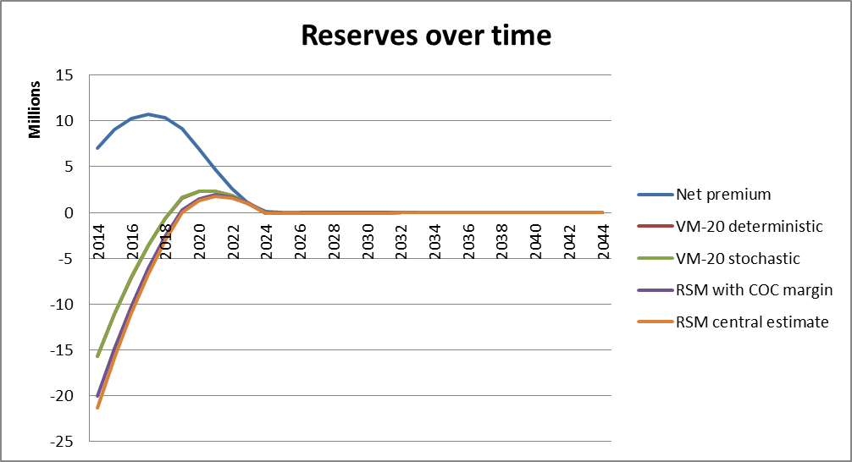
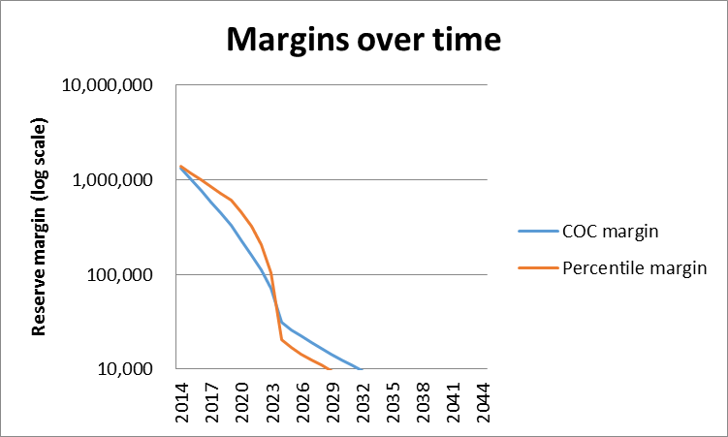
Observations:
- The VM-20 modeled reserves are only slightly higher than the reserve under RSM. This reflects the fact that mortality improvement, which cannot be anticipated in the VM-20 modeled reserves, is a relatively small issue for 10-year level term.
- The biggest reserving issue with 10-year term at young issue ages is the size of the initial sales and underwriting expenses relative to expected claims. Recovery of those expenses is built into renewal premiums, but under the net premium method the expense load in the renewal gross premium is not reflected and the reserve is much higher than necessary.
- Since the COC aggregate margin tends to be smaller than the percentile aggregate margin for shorter term contracts, it is smaller during the remainder of the level term period for this block. However, after the shock lapse at the end of the level period and the significant reduction in size of the remaining block, the COC margin is larger, as is typical for business that still has many years to run.

Age 35, 20 year level term

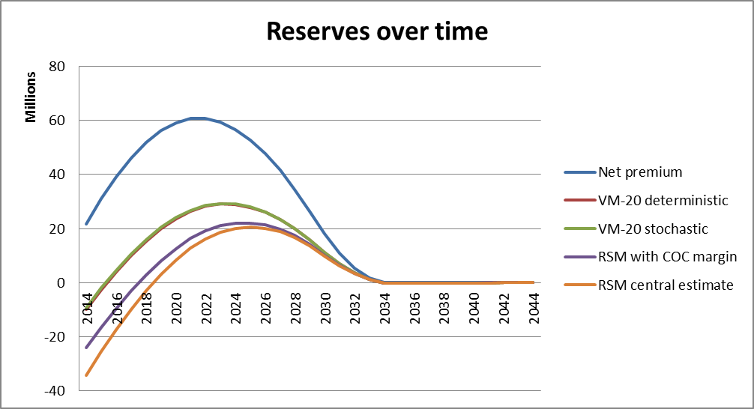
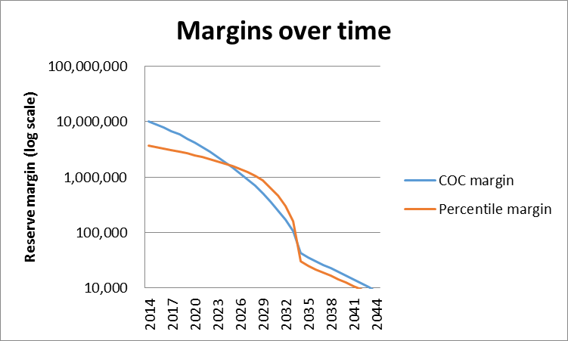
Observations:
- Mortality improvement is a larger issue for 20-year term, and that explains why the difference between the VM-20 reserves and RSM is relatively greater for 20-year level term than for 10-year level term.
- In the first several years the COC margin is larger than the percentile margin, as is typical of business that has a large number of years left to run.

Age 35, 30 year level term

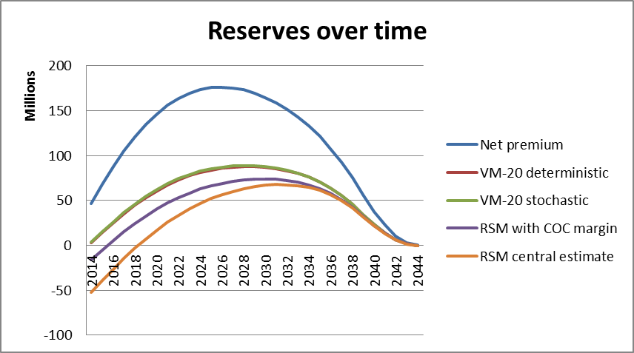
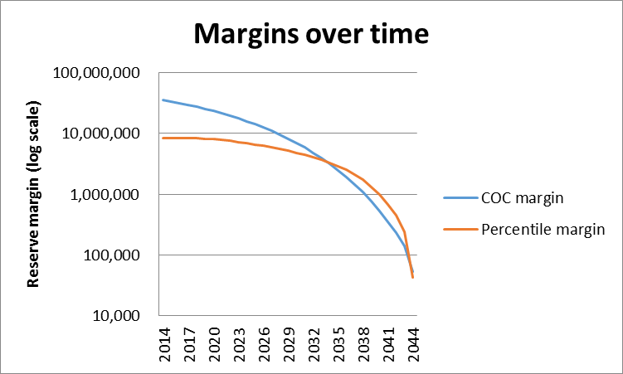
Observations:
- As mentioned above, the excess of the net premium reserve over the VM-20 modeled reserves in this study is caused mainly by the non-recognition of expense recovery built into renewal premiums. It is surprising that even with 30 years over which to spread those expenses, the effect is still significant.
- The COC margin is significantly larger than the percentile margin in the early years.

Age 55, 10 year level term
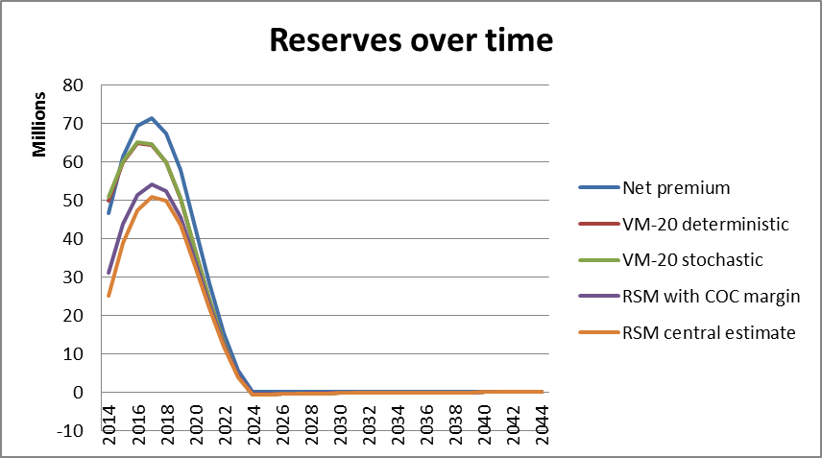
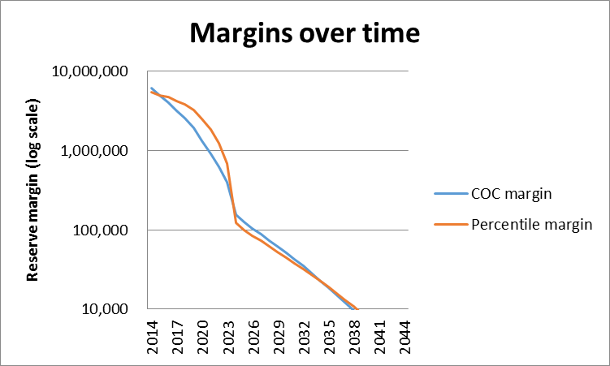
Observations:
- Expenses are much smaller relative to mortality cost for contracts issued at age 55 than those issued age 35. This is reflected by the smaller difference between the net premium reserve and the VM-20 modeled reserves.
- The net premium reserve is actually smaller than the VM-20 modeled reserves on the first valuation date shown. This probably reflects the interaction of several factors including the difference in discount rates and its effect on the size of the net premium compared to the gross premium.

Age 55, 20 year level term

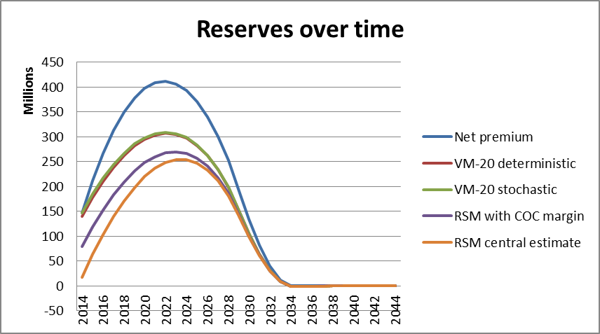
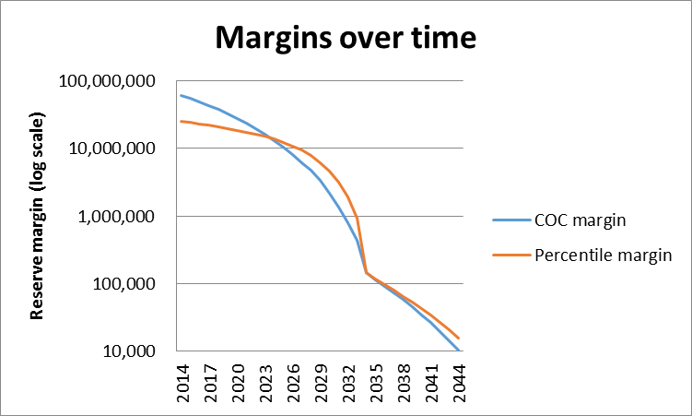
Observations:
- Just as for 10-year term issued at age 55, the net premium reserve is very close to the VM-20 modeled reserves on the first valuation date shown. This implies that at time of issue, the VM-20 modeled reserves could have exceeded the net premium reserve, leading to a loss at issue.
- For every combination of issue age and level term period studied, the RSM reserve with margin is smaller than the reserve under the other methods shown.

For this study, the VM-20 stochastic reserve calculation was slightly modified, in that the scenario amount for each scenario was calculated directly as the present value of future cash flows. In VM-20 the scenario amount for stochastic scenarios is calculated as the value of starting assets plus present value of greatest future deficit, where the present value is taken at 105% of Treasury 1-year rates. When using the GPVAD approach, VM-20 requires that the starting assets be very close to the stochastic reserve. In this model, the starting assets on each valuation date are those that were accumulated by the business under study, so the GPVAD approach could not be applied without extra work and iteration to adjust the starting assets used for valuation at that time. Therefore direct discounting of cash flows was used, as is done for the VM-20 deterministic reserve. The author believes this is a reasonable approximation for the scenario amounts in the stochastic valuation.
Appendix 3 details the approach used to generate the stochastic scenarios.

