# Development of Scenarios for the Modeled Reserve

# Background

The intent of the methodology for the Modeled Reserve is to approximate the reserve that would be determined using a full stochastic reserving approach with stochastic treatment of all major risks. The desire is to approximate that kind of reserve using a process that is less calculation-intensive and more auditable.

In short, the idea is to use a small number of specially constructed scenarios rather than full stochastic testing involving stochastic treatment of all major risks (not just investment risks). The results from the small number of scenarios are to be used in a very mechanical way. This makes the process more transparent and less burdensome. From an audit point of view, it becomes more practical to audit the construction of the scenarios across all major risks and the process by which scenario results are used to calculate both the “best estimate” and the “margin” in a Modeled Reserve.

This paper discusses the development of the small number of specially constructed scenarios. The reader should keep in mind the goal for scenario development, which is that each scenario represents a stress test for a single risk, and each scenario is calibrated to a specific level of severity (or percentile level) in the distribution of all scenarios for that risk.

# The Stochastic Scenario as a Random Walk

The development of a stochastic scenario for one risk, say the rate of claims, typically starts with a stated distribution of the result for one period, say one year. The distribution may be developed in any one of several ways, but it is developed to represent results for a single time period.

When developing scenarios, we are concerned with long periods of time, so the distribution for one time period is just a start. To develop a stochastic scenario we generate a random number between zero and one for each future year, and use that number to look up the simulated result for the year in the distribution of results for the year. In that way, we generate one stochastic scenario that covers many years. We can then develop many, many stochastic scenarios and use them to derive the distribution of results for the process we are studying.

The intent of the methodology for the modeled reserve is to derive the distribution of results using a much smaller number of specially constructed scenarios. In fact, we would like to be able to construct a single scenario that could be used to approximate a specified percentile point on the distribution of multi-year results. In order to do this, we employ the theory of random walks.

One can think of a random walk as the walk of a person, taking one step at a time towards a light in the infinite distance. Each step moves them forward one unit, but since people are not perfect, each step may also veer to one side or the other of a straight path by some amount. If the walker is very tired or drunk, the variation from a straight line might be significant. So each step takes the walker one unit forward, plus some distance to the left or right. One can simulate this kind of walk as a statistical scenario if one assumes a distribution for the size of left or right movement on each step and then generates a random point on that distribution for each step to simulate the size of the movement left or right on that step.

A Gaussian random walk is just such a stochastic scenario wherein the distribution of random left or right movement on each step is a Gaussian or Normal bell-shaped curve. In a Gaussian random walk each step moves one unit forward, and some amount left or right depending on the wideness (variance) of the distribution and the random number generated for that step.

Gaussian random walks have been studied extensively. One key statistic is the distribution of the walker’s position after N steps. It turns out that this distribution is again a Gaussian distribution, and the standard deviation after N steps is the standard deviation after one step multiplied by the square root of N. This is illustrated in Figure 1.

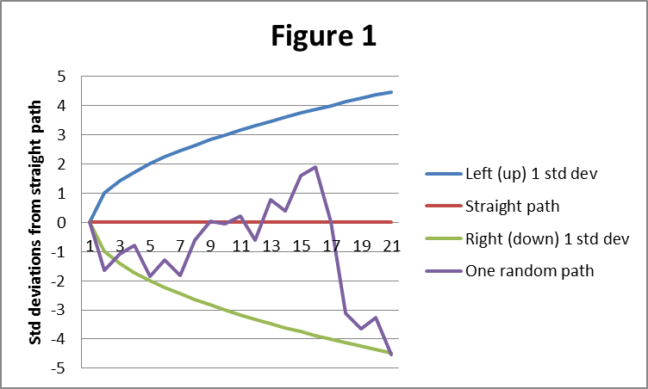

Figure 1 illustrates random walks that begin at zero on the left axis and travel to the right one unit for each time step. The blue and green lines in Figure 1 illustrate how far from the straight path a random walk might wander while staying within one standard error of the straight path, on a cumulative basis. The purple line illustrates one random path. (For illustrative purposes the left and right movements are magnified in this figure.)

In the scenarios we wish to create, the straight path represents anticipated experience and each step in the random walk represents the potential deviation from anticipated experience in one period. The cumulative position of the walker at any time step represents the cumulative severity of the scenario. In this context it is important to observe that if the deviation from expected is the same at each time step in a scenario, the cumulative effect is a scenario that is at a much greater degree of severity than the deviation from expected at any one time step. This would be analogous to a random walk like that illustrated as the “severe cumulative path” in Figure 2.

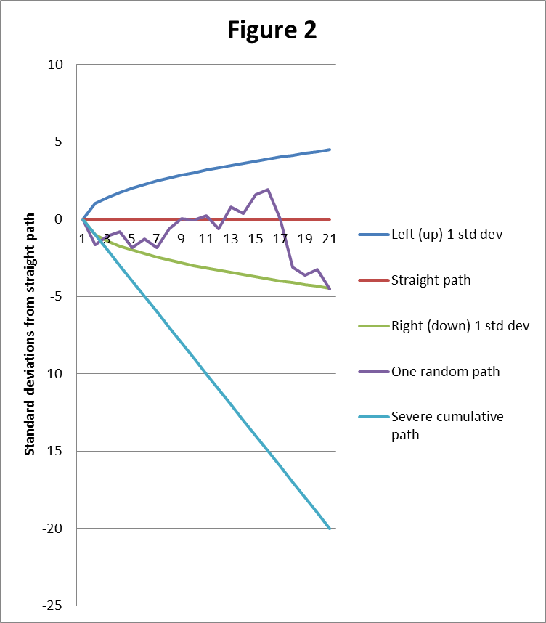

This analysis plays a key role in the technique we use to develop scenarios at a specified probability level over long periods of time. If a scenario is defined by a series of Gaussian random numbers (mean zero, variance one) representing the deviation from anticipated experience at each time step, then the scenario’s cumulative probability level can be defined for our purposes by doing the following:

1. Find the cumulative sum S(T) of random shocks from the beginning to every time T in the scenario (analogous to the Y axis coordinate in Figures 1 and 2)
2. At each time step T calculate S(T) divided by the square root of T.
3. Find the result from step 2 with the largest absolute value, call it M
4. Determine the percentile point corresponding to M on the standard normal distribution. The corresponding percentile is the percentile level we will assign to the scenario.

In the context of Figure 1, that means that a scenario at a percentile level between +1 and -1 standard deviations should follow a path that remains always between the blue line and the green line (-1). The further the scenario deviates from the straight path and approaches the blue or green lines, the further its percentile level deviates from 50%, where 50% represents the median of the distribution.

Mathematically, we define the percentile level of a scenario as follows.

Let the random shock (mean zero, variance 1) in each period t be $X_{t}.$

Let the sum of shocks over N periods be $S\left(N\right)=\sum_{t=1}^{N}{X_{t}}$.

The percentile level expressed as number of Gaussian standard errors from the mean is $\underset{N}{E=max}\left[\left|S(N)\right|/\sqrt{N}\right]$, with a sign (+/-) equal to that of the value of S(N) that had the maximum absolute value.

The percentile level itself is then, using the inverse Gaussian distribution: $P=ψ^{-1}\left(E\right).$

With this in mind, a scenario at the “one standard deviation up” percentile level (84%) is one where $\underset{N}{E=1=max}\left[\left|S(N)\right|/\sqrt{N}\right]$. If we wish for a scenario at a higher or lower probability level, we simply multiply all the random shocks by the corresponding number of standard deviations.

There are two approaches to generating such scenarios (i.e. such paths of random shocks). One is to simply generate a large number of scenarios randomly and then select those that meet the criteria. The other is to manually construct such scenarios.

The following are some ways to manually construct such scenarios.

* **Pop-up scenario: $X_{t}=\sqrt{t}-\sqrt{t-1}$** . The maximum shock occurs in every period, subject to the limit on cumulative shocks.
* **Creep-up scenario over N periods: $X_{t}={\sqrt{N}}/N$**  . The shock accumulates to its maximum only at the end of the period.
* **Up-down scenario:** Follow a creep-up pattern for N periods and then creep down for N months.
* **Delayed stress scenario:**  Shocks are zero for N/2 periods, and then double those of the creep-up scenario for the next N/2 periods. One can argue whether this scenario is more stressful or not, but it satisfies our criteria for a one standard deviation scenario on a cumulative basis measured from the valuation date.

Figure 3 illustrates the paths associated with these scenarios over a period of 20 years.

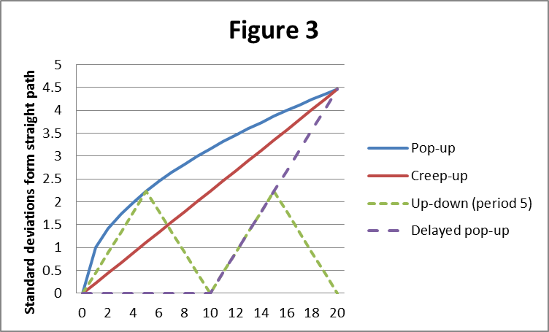

No matter how the scenarios are constructed, an important advantage of this approach to developing a limited set of scenarios is that we use the scenario generator to create them. The random shocks themselves are not the scenario. Instead, they are fed into a scenario generator that translates random shocks into a path of future experience. The scenario generator is assumed to reflect the real dynamics of whatever variable we are dealing with. So, for example, an interest rate generator may include mean reversion as a force that changes the path of interest rates even when shocks are zero. A mortality generator may include a normal rate of mortality improvement that occurs when shocks are zero. A lapse generator may (or may not) retain the effect of prior shocks to adjust the anticipated level of lapses going forward. The fact that the scenarios actually used will reflect the appropriate structural behavior based on the generator makes scenarios developed from low-level random shocks arguably more realistic.

# Defining the assumed probability distributions

## Theoretical basis

Before attempting to quantify the probability distributions, one needs to understand the multiple ways in which deviations from anticipated experience can occur within our models. There are three primary sources of deviation:

1. Pure statistical variation around the mean due to limited sample size
2. Variation due to the fact that the true mean is not perfectly known
3. Variation due to changes in the external environment that drive behavior

In actuarial models, the variation due to changes in the external environment is simulated by dynamically linking the mean of the distribution (the anticipated experience) to some quantitative measure of the external environment. For example, it is common to link the anticipated lapse rate to some function of interest rates in an economic scenario. The link is a deterministic one based on a static formula.

For discussion we will assume dynamic linking is in place in our models, and that the static formula does not include any variables whose value is uncertain. If there were a variable whose value is uncertain, a distribution for potential values could be defined and the variable could be treated as yet another source of risk that must be evaluated. However we will not treat variables in dynamic linking formulas in that manner for the field test. More generally, the construction of dynamic links is a separate subject that is outside the scope of this document.

With dynamic linking in place, the remaining sources of variance from anticipated experience are statistical in nature. The pure statistical variation of an actuarial decrement around the mean due to limited sample size can be modeled using either the Poisson or Binomial distribution. For those distributions there are simple formulas that provide the distribution of results for a sample of any given size, assuming the true mean is known.

That leaves the issue of the uncertainty of the true mean. There are statistical techniques that can derive an estimate of the distribution of potential results given data from a limited (non-infinte) sample that provides only an approximation to the mean. This distribution will have greater variance than the pure Poisson or Binomial with known mean. These are the techniques that should form the theoretical basis for the distributions to be used in our models[1].

Several issues arise in connection with using this theoretical basis for these distributions:

1. The distributions will be wider for small companies that have a more limited sample size in their actual experience. Regulators will need to decide the degree to which company size should influence reserving and capital requirements. Limits might be placed on the range of variability by company size.
2. The experience studies used should somehow filter out the effect of behavior dynamically linked to the environment when deriving the baseline experience. This might be done by limiting the period of observation so that the economic environment does not change much during the period of observation, but that is not always possible.
3. Several different statistical techniques might each provide the kind of estimates of the distribution that are required. Additional discussion and research may lead to standardization on the most appropriate technique for each kind of risk.

## Scenario generation procedure

Conceptually, the process to generate a scenario for any risk variable is as follows:

1. Generate a series of Gaussian random deviates (mean zero, variance one). This series can be generated to follow one of the patterns shown in Figure 3 and scaled to the desired level of severity.
2. Translate each random deviate from step 1 into a value from the distribution of the risk variable.

This of course assumes that we have the distribution of the risk variable and can easily determine the value at any percentile level. For purposes of specifying the scenarios in our field test, we will specify the distribution of each risk variable using only five points on its distribution: +/- 3 standard deviations (0.1% and 99.9%), +/- 1 standard deviation (16% and 84%) and the median (50%). If we are given a Gaussian random deviate with mean zero and variance 1, it is an easy task to linearly interpolate between two of our five points (-3, -1, 0, 1, 3) to approximate the desired value from the distribution. If the value were outside the range of +/- 3 we could extrapolate, but we do not expect to need to do that given the way we will specify the scenario of random deviates.

The example below illustrates how this approach would be used to create a pop-up scenario of lapse rates at the 99.9% (+3 standard deviation) level. The lapse rate in each period would be the anticipated lapse rate plus an add-on deviation taken from the “interpolated value” column in the example. The interpolated value for period 2 is based on 1.2426 standard deviations and is interpolated between the values for 1 and 3 standard deviations in the specified distribution shown on the left.



Linear interpolation using just 5 points from the specified distribution is understood to be approximate. However, it provides a simple, practical, and easily auditable way to create scenarios for this purpose.

The scenario generation approach discussed so far can be applied well to risk variables whose distribution is typically studied and measured over a single period. There are some risks, however, whose distribution is typically discussed only in the context of the entire duration of the contract. A scenario at a specified percentile level for such a variable would consist not of a series of values but rather a single value which remains constant over the life of the contract. Two such risk variables are:

* The rate of mortality improvement as a multiple of a projection scale
* The utilization adjustment for “in-the-moneyness” as a multiple of the normal adjustment

## Assumptions required for scenario generation

With all of the above in mind, the following assumptions are needed for purposes of scenario generation in the field test:

Lapse rates

* Table for anticipated experience
* Add-on for annual shocks at +3, +1, -1, and -3 standard deviations
* Multiplier for annual shocks at +3, +1, -1, and -3 standard deviations

Mortality rates

* Table for anticipated experience
* Mortality improvement scale for anticipated experience
* Improvement scale multiplier for lifetime shocks at +3, +1, -1, and -3 standard deviations
* Mortality rate multiplier for annual shock at +3, +1, -1, and -3 standard deviations

GLIB and lifetime income election rates

* Standard table (developed by ARWG) which includes base rates and ITM modifiers
* Multipliers for ITM modifiers at +3, +1, -1, and -3 standard deviations (to be developed by ARWG or invented by CRC after ARWG specifies standard table)

Expenses

* Unit costs for anticipated expenses (sample breakdown below)
  + Variable, e.g. % of contract value
  + Fixed, e.g. per contract, per transaction
* Multipliers for total fixed costs at +3, +1, -1, and -3 standard deviations
* Reminder – inflation will be applied to fixed costs on top of any multipliers

Interest rates and equity market returns

* All anticipated experience and shocks to be based on the VM-20 scenario generator

1. These are the techniques that Tom Rhodes and others have developed in connection with their long experience with statistical studies of this nature.