Contents
Introduction 2
Background 2
Product description 2
Reserving issues for ULSG 3
Representative Scenarios Method Demonstration 5
Steps 1, 2 and 3 5
Step 4 7
Step 5 7
Step 6 7
Analysis 8
Comparison of RSM to Other Methods 8
Margins 9
Risk breakdown over time 10
Aggregate margins over time 11
Aggregate margins compared to full stochastic modeling 13
Appendix 1: Product description and assumptions 16
Appendix 2: Developing distributions for each risk driver 18
Appendix 3: Modeling AG38 reserves 21
Effect of the 2017 CSO 21
Appendix 4: Generation of full stochastic scenarios 23

Prepared by Stephen J. Strommen FSA, CERA, MAAA
December 15, 2015

Introduction

This paper is an extension of the introductory overview document titled “Representative Scenarios Method”. In order to appreciate the case study presented in this report, the reader is advised to gain a fundamental level of understanding of the Representative Scenarios Method (RSM), in particular, the six steps involved in deriving a reserve using the RSM. These six steps are summarized below, and referred to throughout this narrative.
Step 1: Identify blocks of business with substantially similar risks. Identify the block’s key risk drivers (KRDs), which are those assumptions whose variability can significantly affect the cost of fulfilling the contract.
Step 2: Determine the distribution of assumption values for each KRD.
Step 3: Generate scenarios for each KRD within its distribution. The five scenarios used in this study are the median, +/-1 standard deviation and +/- 3 standard deviations. This is consistent with the overview document. The total number of scenarios necessary for the determination of the RSM reserve is equal to 1 + (number of KRDs)*(number of scenarios per KRD – 1)
Step 4: Project asset and liability cash flows. In this step, each scenario is assigned a scenario reserve. The scenario reserve is the level of starting assets required to satisfy all liability cash flows until the contracts expire.
Step 5: Calculate a central estimate as a weighted average of the scenario reserves. Within each KRD, the scenarios are assigned probability weights. Each KRD is also assigned a weight. Combining the scenario reserves using these weights determines the central estimate of the reserve prior to margins.
Step 6: Add an aggregate margin to the reserve. Two alternate approaches are proposed for calculating the aggregate margin – the cost of capital approach and the percentile approach. The results of both are presented and compared in this study.

Background

Product description

Universal life insurance with a secondary guarantee provides a fixed benefit amount upon death at very low cost. The basic contract takes the form of universal life insurance with flexible premiums. A secondary guarantee ensures that coverage will remain in effect even if the contract’s account value declines to zero, as long as a shadow fund remains positive. The premium level needed to keep the shadow fund positive is much lower than that needed to keep the account value positive. This leads to the two main characteristics of a ULSG contract: a low premium for lifetime coverage and a small or zero surrender value.
Because of the small or zero surrender value, lapse rates on ULSG contracts tend to be very low. Most policy owners pay the minimum level premium needed to keep the shadow fund positive for life. The contract is often sold in situations where a death benefit is needed to supply cash for estate liquidation. Given this use of the contract, most sales are at older ages after an estate has been accumulated.
The ULSG contract used for this study is meant to represent the competitive low-premium end of the estate protection market. When the minimum premium is paid, the account value never accumulates to much and goes to zero fairly quickly. For purposes of this study, all policy owners are expected to pay the minimum level premium, since there is no need or incentive to pay a higher premium, and payment of a lower premium can lead to termination of coverage before death. Two different ULSG contracts were priced for this study, male issue age 50 and male issue age 70.

Reserving issues for ULSG

The appropriate level of reserves for ULSG contracts has long been a subject of debate. Since the shadow fund is never paid in cash, it can be defined in many ways and this has made it difficult to define a formulaic reserving approach that works in all cases. There are three major assumptions about future experience that have been the subject of debate:
- The small to zero surrender value makes the contract lapse-supported, so assumed lapse rates affect the reserve significantly.
- The trend of mortality improvement leads to significant uncertainty about the timing of future death benefits.
- The collection of premiums over a long future time frame leads to significant uncertainty about future investment returns.
The development of principle-based reserves and VM-20 has addressed these concerns to some degree. However, industry is still concerned that reserves under VM-20 are larger than needed due mainly to the rules for setting assumptions and margins within the principle-based approach.
One way to think of the Representative Scenarios Method is as principles-based approach with three main differences from the stochastic reserve in VM-20:
- The insurer is allowed to use its own estimate of anticipated experience, subject only to audit and examination. There is no requirement that the assumption be supported by relevant and credible company or industry data; but common sense indicates that the assumption should reflect such information if it exists.
- The margin is calculated from a small number of scenarios (or stress tests) using a framework defined by the regulator, but making use of internal company data where available.
- The number of scenarios that must be evaluated is far fewer than stochastic modeling.

Representative Scenarios Method Demonstration

Steps 1, 2 and 3

The following paragraphs describe the six KRDs identified for the ULSG product (i.e. Step 1); the distribution of each KRD’s values (Step 2); and the 5 scenarios within each KRD distribution (Step 3).
The choices made for this study are those of the author and are based on a combination of professional judgment and statistical technique.
- Mortality statistical fluctuation. To simulate this risk, mortality rates for each year are multiplied by a value that indicates the level of experience in that year relative to expectations. When the value is 1.0, mortality is as expected. The distribution of the multiplier for any single year is defined by this table, which is based on statistical fluctuation for a block of business that expects about 100 death claims per year.
Percentile | Multiplier
99% | 1.34
84% | 1.11
50% (anticipated) | 1.0
16% | 0.90
01% | 0.73

- Mortality improvement trend. To simulate this risk, mortality improvement scale G was multiplied by a value that indicates the level of improvement relative to expectations. The distribution of the multiplier is defined by the table below. Values in this table are highly subjective because the distribution of future mortality improvement is largely unknown, though the level of historical improvement has been studied for many years. Regulators may wish to specify the values that should be used. Note that the value currently used for regulatory purposes is zero, which this table suggests is at the low end of the distribution. For this risk driver, the same multiplier is used for every time period in a scenario. This means that mortality improvement at any particular attained age is assumed to persist indefinitely, although scale G does reflect slower improvement at higher attained ages.
Percentile | Multiplier
99% | 1.25
84% | 1.15
50% (anticipated) | 1.0
16% | 0.7
01% | 0.0

- Lapse rates. To simulate this risk, lapse rates for each year are adjusted by adding a value that indicates the level of experience in that year relative to expectations. When the added value is 0.0, lapse rates are as expected. The distribution of the add-on for any single year is defined by the table below. Since the anticipated lapse rates are 2% for the first five years and 1% or zero thereafter, the adjusted lapse rates below the 50% level are often zero (lapse rates cannot be adjusted below zero).
Percentile | Add-on
99% | 0.03
84% | 0.01
50% (anticipated) | 0.0
16% | -0.01
01% | -0.03

- Interest rates. To simulate this risk, scenarios are defined by the series of “random” shocks used in the VM-20 interest rate scenario generator. The development of the series of shocks is described elsewhere, but uses the same methodology as was used for the scenarios in the VM-20 stochastic exclusion test.

- Default costs. To simulate this risk, default costs for each year are adjusted up or down by an additive amount. The additive amount is a multiple of the default cost margin specified in VM-20. The multiples used are defined by the table below. Note that this risk is asymmetric because default costs can increase much more than they can decrease. For this risk driver, the same multiplier is used in every time period in a scenario.
Percentile | Add-on
99% | 3.0
84% | 1.0
50% (anticipated) | 0.0
16% | -0.5
01% | -1.0

- Expenses. To simulate this risk, home office expense unit costs for each year are multiplied by a value that indicates the level of expense for that year relative to expectations. When the value is 1.0, expenses are as expected. The distribution of the multiplier is defined by this table:
Percentile | Multiplier
99% | 1.1
84% | 1.02
50% (anticipated) | 1.0
16% | 0.98
01% | 0.90

Step 4
An actuarial model depicting the ULSG product portfolio was run over the 25 scenarios described above (anticipated, plus 6 KRDs over 4 non-baseline scenarios). Each of the 25 runs results in one scenario reserve.

Step 5
Probability weights were assigned to each of the 5 scenarios within each KRD. These weights are prescribed as part of RSM. Then each KRD was assigned a weight based on the range of scenario reserves for that KRD, so that a KRD with a wider range of scenario reserves gets greater weight. The combined result provides the weighted average scenario reserve that is used as a central estimate before adding margins.

Step 6
Margins were added. For this study two different approaches were used to calculate an aggregate margin – the cost of capital approach and the percentile approach. Further discussion of these approaches and the results is included in the next section.

Analysis

Comparison of RSM to Other Methods

To get a general understanding of the level of reserves under RSM for ULSG, we first study a simulated block of such business. The simulated block of business is limited to contracts issued during 2014, with equal amounts of business issued in each month of 2014. All contracts were issued to males with the number of contracts and amount of insurance split equally between issue age 50 and issue age 70. For purposes of projecting results over time, the interest rate scenario is flat with 20-year Treasuries at 4.0%.

The chart below shows the level of reserves over time for the block of ULSG business in this case study.
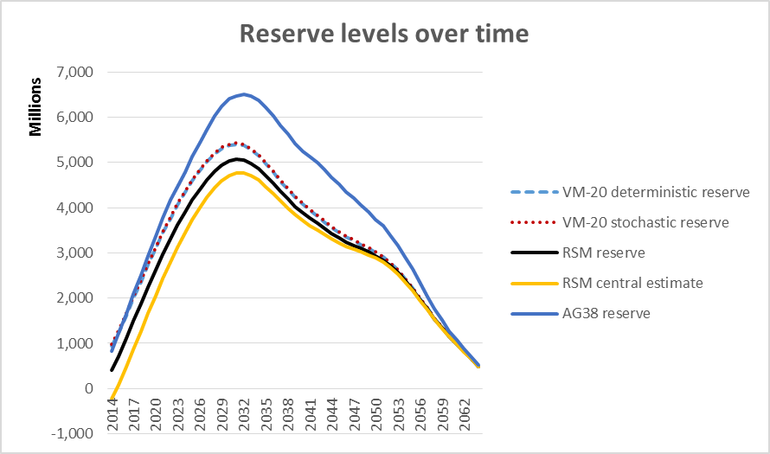

The difference between the reserves shown above can be roughly attributed to adding various margins as follows, starting from the smallest reserve shown:
- The RSM central estimate includes no margin, so it too small for a reserve.
- The RSM reserve includes a cost-of-capital (COC) margin, arguably a sufficient aggregate margin.
- The VM-20 reserves add additional margin mainly because future mortality improvement cannot be reflected. The chart below shows that the difference between the VM-20 stochastic reserve and the RSM reserve tracks closely with the effect of disallowing the mortality improvement assumption in the PV of cash flows. Note in the chart above that the VM-20 stochastic and deterministic reserves are very close together.
- The AG38 reserve adds another layer of margin because lapse rates are not reflected, discounting reflects a conservative investment yield, and mortality rates are based on a conservative valuation mortality table.
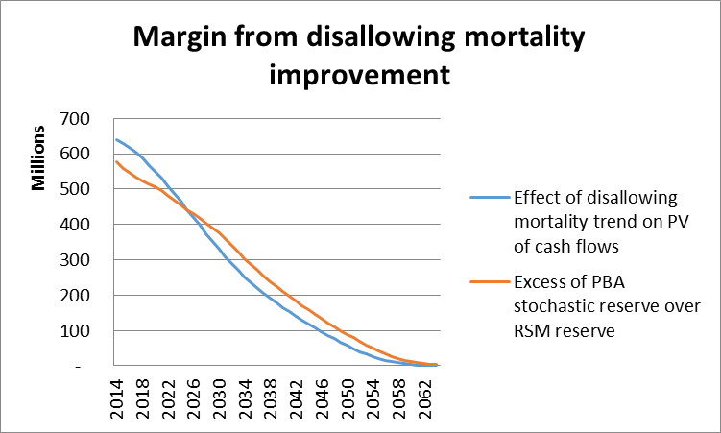

Margins

The various scenario reserves produced using the RSM provide substantial information about the size of various risks, and that information can be used to calculate an aggregate margin under either the cost of capital approach or the percentile (CTE) approach. The first subsection below illustrates the breakdown of risks over time, and the second shows the results of applying that information to calculate an aggregate margin under either approach being considered.

Risk breakdown over time

The range of scenario reserves for each KRD (i.e. the minimum and maximum produced by the five scenarios within each KRD) provides information about the size of the risk posed by that risk driver. The excess of the highest scenario reserve over the anticipated scenario reserve represents the total loss relative to expectations that could arise from that KRD in the most adverse representative scenario, and is referred to as the risk amount. That figure can be used to measure the size of that risk in the context of total risk.
The chart below illustrates the size of each risk amount in the sample block of business over time.
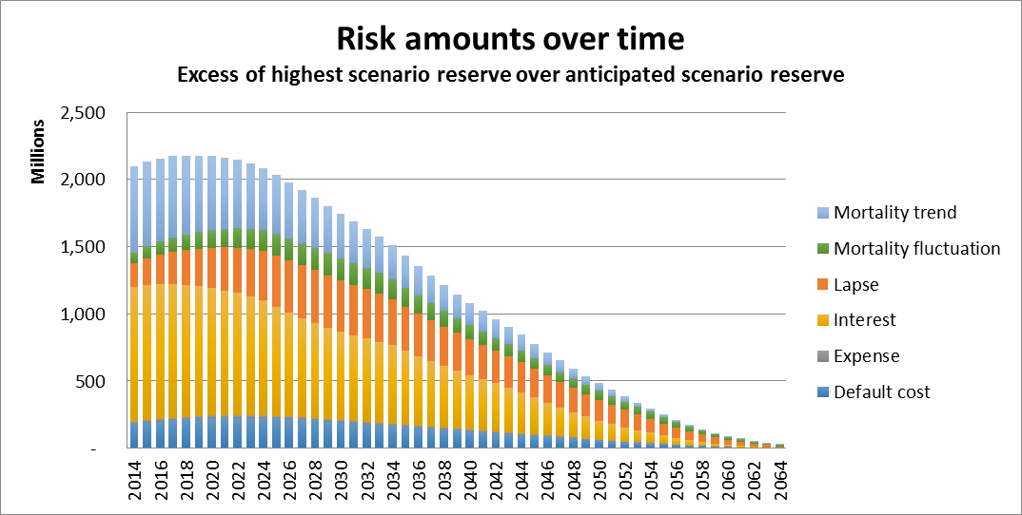
The following observations arise from the breakdown of risks over time:
- The largest risk is the interest (i.e. reinvestment) risk. Since most of the premium will be received many years in the future, uncertainty about interest rates available in the future is a major contributor to total risk.
- Mortality improvement and lapse rates compete to be the second largest risk. Lapse risk is surprisingly large given the low level of anticipated lapse rates on ULSG. It is the extreme case where lapses decline to effectively zero that creates this risk.
- Default cost risk is substantially smaller than interest rate risk.
- Expense risk is not material. Therefore it would not need to be included as a Key Risk Driver.

Aggregate margins over time

The information provided by the RSM concerning the size of each risk can be applied to calculate an aggregate margin under either of two approaches – the cost of capital approach and the percentile or CTE approach.
The cost of capital approach is much like the “transfer value” approach to Margin over Current Estimate that is discussed in international capital deliberations. Under the cost of capital approach, one calculates the margin in four steps:
- Aggregate the total risk amounts together to get a total aggregate risk amount or initial capital requirement. This aggregation can be done in the same manner that the RBC formula aggregates C-1, C-2, C-3, and C-4 risks, using a square-root of sum of squares formula.
- Project the initial capital amount forward in time in proportion to the remaining present value of benefits at any point in time, based on the anticipated experience scenario.
- Multiply the projected capital amounts by a cost of capital rate such as 6% in order to get a projected cost of capital for each future year. This 6% factor could be adjusted by regulators to calibrate the margin to a desired level.
- The aggregate margin is the present value of the projected future cost of capital amounts, using discount rates from the anticipated experience scenario.
Under the percentile approach, one uses information from different scenarios. Rather than the most adverse scenarios for each risk driver (which define the “risk amount”), one uses the scenario reserves at the 1-standard deviation level. For each risk, a “margin risk amount” is the excess of the largest of the 1-standard deviation scenario reserves (either the plus 1 or the minus 1) over the central estimate (the weighted average scenario reserve from step 5). Given these “margin risk amounts” the calculation of the aggregate margin can be a single step:
- Aggregate the “margin risk amounts” together to get a total aggregate margin. This aggregation can be done in the same manner that the RBC formula aggregates C-1, C-2, C-3, and C-4 risks, using a square-root of sum of squares formula.
Of course this calculation reflects a percentile level corresponding to 1-standard deviation rather than a CTE. If one wishes to apply the theory behind the CTE, one could modify the estimate of the “margin risk amount” for each risk driver so that it is based on a blend of scenario amounts at different levels of severity rather than just one level of severity. The scenario amounts at other levels of severity could be interpolated or estimated in some other fashion that doesn’t require running more scenarios.
The chart below compares the aggregate margins under the two methods over time. A log scale is used for the vertical axis so that proportional differences remain visible even as both margins get much smaller in dollars as the business runs off the books.

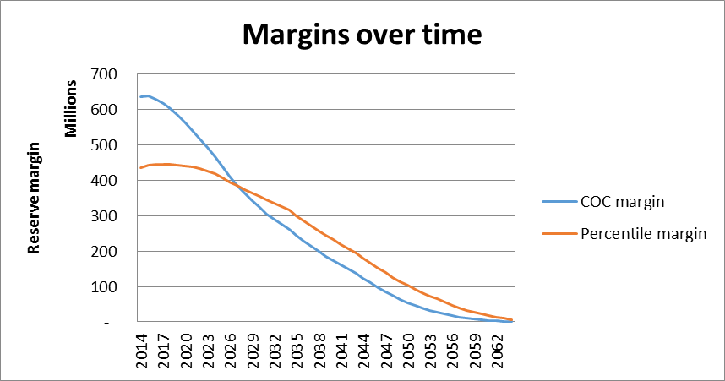
The main difference between these two margin methodologies is apparent from this graph. The COC margin tends to be larger when the business still has a long period to run. However, the COC margin is released faster, and becomes lower than the percentile margin as the business approaches expiry.
The difference arises because the COC margin is the present value of an annuity where each payment is for the cost of capital. The larger the number of payments remaining, the larger is the present value and the larger the COC margin. In contrast, the percentile margin is based on the stochastic distribution at a snapshot in time and is less dependent on the amount of time remaining.
The chart below provides another perspective – the margin as a percentage of the aggregate risk amount from the previous subsection. Again we see that the COC margin starts higher (when the contracts still have decades to run) but runs off faster.

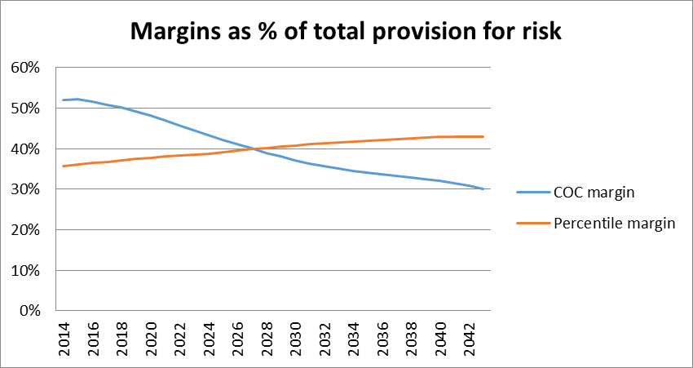

Aggregate margins compared to full stochastic modeling

Some observers are skeptical that the small number of scenarios used in the RSM will provide a usable approximation to the results of full stochastic modeling. To study that issue, full stochastic valuations using 1000 scenarios were carried out at each valuation date. These stochastic scenarios treated every Key Risk Driver stochastically, not just investment returns.
The chart below shows the percentile level margin based on full stochastic modeling and compares that with the aggregate margin (percentile approach) estimated using RSM. Two different percentile levels are shown. One is the level associated with the reserve (CTE70 or approximately 1 standard deviation) and the other is the level associated with the total asset requirement (CTE 99.8 or 99.9th percentile or approximately 3 standard deviations). The results show that in this case study the margins estimated using RSM are more conservative than those estimated using full stochastic analysis. This contrasts with the results previously obtained for level premium term, where the margins estimated using RSM were closer to those from full stochastic analysis. This difference in results remains under study.
While the chart focuses on percentile levels, it should be understood that a margin based on the cost of capital (COC) approach would use the higher of the two percentiles as the basis of the initial capital requirement. The COC margin is proportional to this estimated capital requirement. Therefore the aggregate margin on a cost of capital basis in this study is slightly larger using the RSM results than using the full stochastic results.

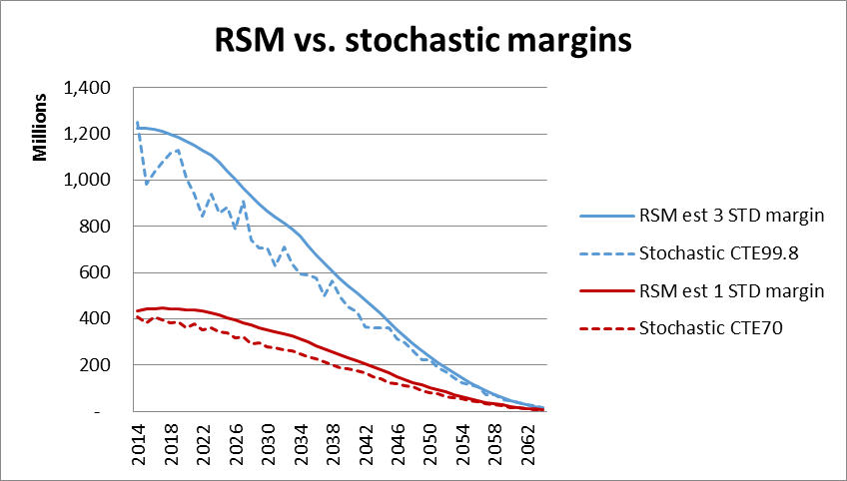
While the RSM estimate of the percentiles is higher than estimated using full stochastic modeling in this study, it is worth bearing in mind that the stochastic results are subject to estimation error. The chart below illustrates the 95% confidence interval for the CTE70 based on a sample of just the first 100 scenarios out of the 1000 scenarios that were used. 100 scenarios is a much larger number of scenarios than were used to obtain the RSM figure. Nevertheless the RSM estimate appears to be on the edge of the confidence interval for the stochastic CTE70 estimate using 100 scenarios.
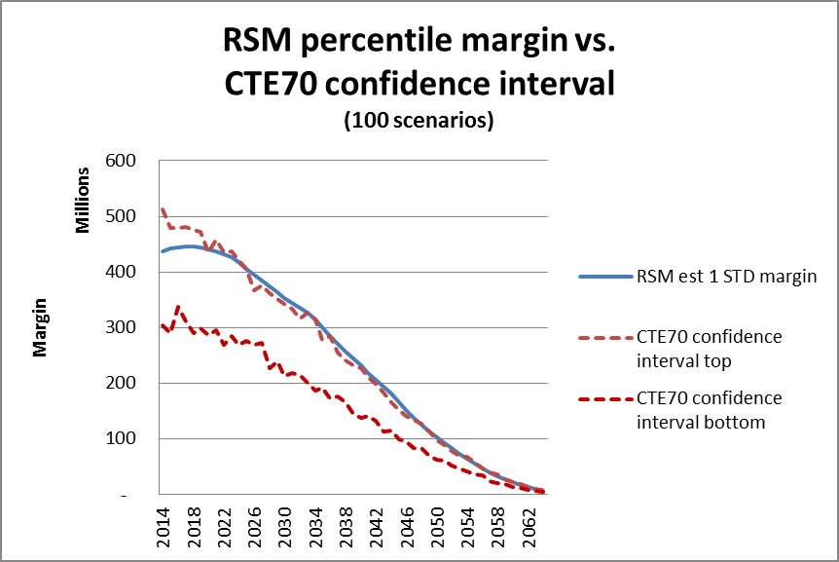
With the focus here on differences between various calculations of the margin, it is easy to lose sight of the big picture. The margins are a small part of the reserve, so even though margins are different, the reserves under RSM and full stochastic approaches are similar, as shown in the chart below. Relative to the size of the reserve, the differences in margins are barely visible, even though the graph is elongated vertically to magnify the differences. Also, the difference between RSM reserves and the stochastic reserves is much smaller than the difference between any of those reserves and VM-20 reserves.

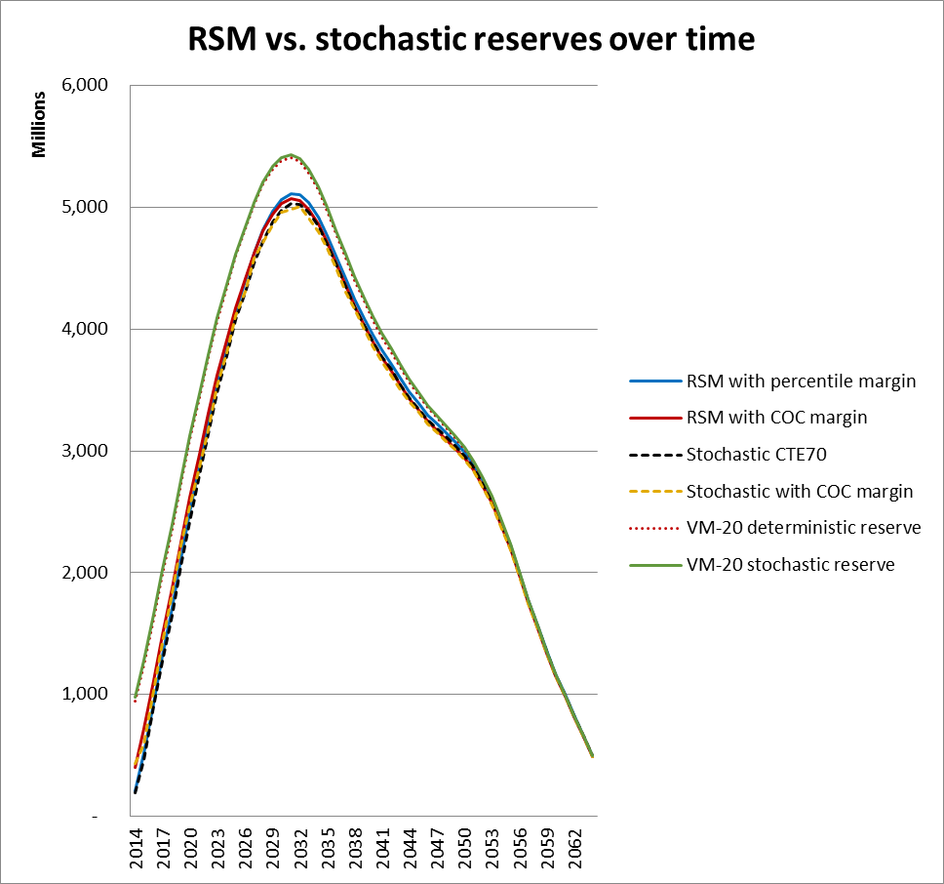

Appendix 1: Product description and assumptions

Product features:
- Universal life contract with secondary guarantee based on a shadow fund
- Parameters for accumulating the account value
  - Interest: 3.00%
  - Cost of insurance: 2001 CSO select and ultimate
  - Expense charge
    - First year: 50% of premium + $1000 per policy
    - Later years: 20% of premium + $100 per policy.
- Parameters for accumulating the shadow fund
  - Interest: 5.75%
  - Cost of insurance: 110% of anticipated experience
  - Expense charge: % of premium, declining by policy year according to this table:
Policy year | % of premium expense charge
1 | 35%
2 | 30%
3 | 25%
4 | 20%
5 | 15%
6 | 10%
7 | 9%
8 | 8%
9 | 7%
10 | 6%
11+ | 5%

Issue ages:
- 50 (male only)
- 70 (male only)

Pricing assumptions:
- Mortality:
  - 60% of 2008 VBT Male Nonsmoker ALB Select with improvement from 2014 at scale G.
- Lapse rates:
  - 5% first year, 2% years 2-5, 1% thereafter
- Interest rate earned: 6.00%
- Distribution costs:
  - 100% of premium first year, 30% year 2, 10% years 3-4, 5% year 5, 2% thereafter
- Maintenance costs:
  - $1000 per policy first year, $75 per policy each year thereafter
  - 2.0% premium tax

Risk drivers for the Representative Scenarios Method:
- Mortality
  - Statistical uncertainty
  - Uncertain rate of improvement
- Lapses
  - Statistical uncertainty
- Interest rates
- Default costs
- Expenses

Pricing (annual premiums for $1,000,000 death benefit)
- Male age 50: $ 9,912.82
- Male age 70: $35,987.63

Appendix 2: Developing distributions for each risk driver

In the body of the paper, numerical risk distributions are documented for each risk driver. Since reserve margins (and potentially capital requirements) could be based on those distributions, they need to be developed in a scientific manner. This appendix describes the blend of science and judgment that was used to develop the distributions used here. Some comments on potential regulatory guidelines are included.

Mortality statistical fluctuation
There are well-established statistical models that can be used to develop the distribution of mortality when the expected level is known. Tom Rhodes of MIB, Inc. documented an approach based on the Poisson distribution that can be used when a study of recent experience is available, based on an underlying mortality table. The distribution can be expressed in terms of the ratio of actual claims to expected claims.

The following formulas can be used to calculate a confidence interval at any desired percentile level around the A/E ratio.
Lower bound = $\left(\frac{A}{E}\right)×{\left[1-\frac{1}{9×A}-\frac{Z}{3×\sqrt{A}}\right]}^{3}$ Upper bound = $\left(\frac{A+1}{E}\right)×{\left[1-\frac{1}{9×\left(A+1\right)}+\frac{Z}{3×\sqrt{A+1}}\right]}^{3}$
where:
A = actual deaths
E = expected deaths
Z = width of the confidence interval in units of 1 standard deviation. For a 95% confidence interval, Z = 1.96. For a (1-α) confidence interval, Z is the value of the inverse normal distribution function at 1-(α/2).

In this study we used values of Z=1 and Z=3 to get points on the distribution 1 and 3 standard deviations from the mean. We assumed the experience study included 100 deaths, and therefore used A = E = 100.

Mortality improvement trend
It is much harder to develop a statistical model for the future trend of mortality improvement because the effects of future changes in medical treatment and technology are unknown. The best that can be done is to study the past trend and put a range around extrapolation of that trend.

The past trend has been captured in various mortality improvement scales. These scales tabulate the annual rate of improvement by attained age, and sometimes by sex. To put a range around such a scale, one can multiply its values by a number greater than 1 for faster improvement and by a number less than 1 for less improvement. Mortality deterioration would be reflected by a multiplier less than zero.

For this study we used a range of multipliers between zero and 1.25 to represent the distribution of mortality improvement. The multiplier does not vary by year within a scenario; it is set at the beginning of the scenario and remains constant.

Since this assumption involves so much judgement, one can expect that regulators will want to specify the distribution to be used for the mortality improvement trend. Ideally, the same distribution would be specified for both life insurance (where faster improvement is favorable for the insurer) and annuities (where faster improvement is costly to the insurer). Use of different distributions for those different products is a major source of implicit or hidden margins in current reserving practices.

Lapse rates
Lapse rates are much like mortality rates in that well-developed models exist for statistical fluctuation around expected experience. But many insurers have found that experience tends to fluctuate more over time than pure statistical fluctuation would suggest.

In many cases, fluctuation in lapse rates seems driven by changes in interest rates. It is common for cash flow projection models to include a dynamic lapse rate adjustment based on changes in interest rates. Changes in lapse rates due to such a function are over and above the variation due to statistical variation, so one still needs to estimate something for statistical fluctuation.

Even adjusting for the effect of interest rate changes, many companies have found that lapse rates seem to have some sort of secular trend that makes them change over time more than pure statistical fluctuation would suggest. Causes may include things like the effect of economic conditions on the ability to continue paying premiums. Because of this, use of a formula like that used for mortality statistical fluctuation produces a narrow distribution that does not encompass actual experience over time.

With these points in mind, the distribution of lapse rates for this study was based on two decisions:
- There will be no interest-sensitive dynamic lapse adjustment. Such an adjustment is most commonly used when cash surrender values are significant, and this product has very low to zero cash values.
- The size of lapse rate fluctuations will be larger than pure statistical fluctuation would suggest. This is purely a judgement call. Since the anticipated lapse rates are very low to begin with, the expected fluctuations are also small, but the range is wider than pure statistical fluctuation would suggest.

For regulatory purposes, one can expect that a scientific measure of pure statistical fluctuation might be prescribed as a means to develop a minimum range for the distribution of future lapse rates. Some sort of dynamic lapse adjustment formula might also be specified as a floor, with different parameters for different products.

Interest rates
For this study we used the interest rate generator adopted for VM-20. For interest rate spreads by credit rating, we used the spread tables that are included in VM-20.

Default costs
VM-20 includes a table of standard default cost assumptions, including margins. It also includes a table that documents the margin included in those assumptions.

For this study we used those tables to develop a distribution of default costs. The central estimate was set equal to the VM-20 standard assumption with the margin removed. The value at the 84th percentile (+ 1 standard deviation) was set equal to the central estimate plus the margin, since the margin was set to approximate CTE70, ad that is roughly 1 standard deviation above the mean. The value at the 99th percentile (+3 standard deviations) was set by multiplying the margin by three. It was assumed that the distribution was asymmetric, since defaults cannot go below zero. Therefore judgment was used to set the value at the 16th percentile (-1 standard deviation) to -0.5 times the VM-20 margin and the value at the 1st percentile (-3 standard deviations) at -1.0 times the VM-20 margin. Percentile points at any other distance from the mean were then interpolated or extrapolated between these values.

Expenses
For this study, the distribution of expenses around the anticipated value was purely based on judgment and historical observation of unit costs in large insurance companies. The anticipated amount of expenses reflects inflation at a rate equal to the scenario-specific path of the 10-year Treasury bond rate less 2%. Based on those assumptions, expense fluctuation is not a significant risk driver for ULSG.

Appendix 3: Modeling AG38 reserves

Statutory reserves for the ULSG product used in this study are currently specified by Actuarial Guideline 38. AG38 specifies a complex, multi-step calculation process that involves a standard mortality table, X factors, and policy provisions including shadow fund calculations.
When pricing the contracts used in this study, the potential level of the reserve under AG38 was kept in mind. In particular, the slope of shadow account COI charges was adjusted to ensure that the basic segmented reserve was small and the segments short. In addition, the slope of the X factors by age was adjusted (subject to the overall constraints on X factors) in an attempt to minimize the deficiency reserve.
While it was relatively easy to ensure the basic segmented reserve was small, the deficiency reserve remained stubbornly large. This is, of course, due to the low level of the gross premium required to keep the contract in force under the terms of the shadow fund. Pricing assumptions include both lower future mortality (due to improvement over time) and higher future investment returns than AG38 allows for valuation.
For the contracts in this study, the first year deficiency reserve is $47 per thousand at issue age 50 and $29 per thousand at issue age 70. The larger deficiency at issue age 50 probably results from the mortality improvement assumption used when setting the gross premium. At issue age 50 there are 20 more years for mortality to improve.

Effect of the 2017 CSO
In the near future a new statutory valuation mortality table will replace the 2001 CSO used in this study. Therefore we reviewed the potential effect of the new 2017 CSO table on the reserves for these contracts under AG38. To our surprise, the use of X factors offset most of the change in reserves that the new table might be expected to create.
The mortality experience rates assumed in this study are slightly lower than those in the super-select nonsmoker male version of the 2017 CSO. Therefore X factors would be used in calculating the reserve under AG38. However, the X factors used in connection with the 2017 CSO would be much higher than those used with the 2001 CSO. We adjusted the X factors used with the 2001 CSO by assuming the product of the tabular mortality rate and the X factors would be unchanged since we are not changing our assumed actual mortality experience. Therefore we increased all the X factors by the ratio of the tabular mortality rates (2001CSO / 2017CSO) at the corresponding age and duration.
With this change to both the mortality table and the X factors, the reserve under AG38 changed very little. In fact, the only part of the calculation that changed at all was the basic segmented reserve, where the segment breaks occurred at different durations because of the slightly different slope of the 2017 mortality rates by age.
The chart below shows the path of the AG38 reserve over time under both tables. As shown, the difference between the reserves on the two tables is barely visible in the graph, and is not always in the same direction. As a percentage, the largest difference is 3.99% in 2020, with the reserve based on 2017 CSO being lower. When averaged over the entire projection period, the reserve based on the 2017 CSO is 0.7% lower.
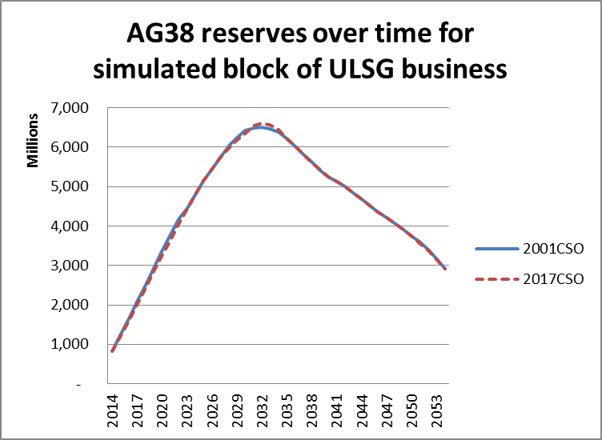

Appendix 4: Generation of full stochastic scenarios

Stochastic scenarios used for regulatory reserving have in the past been stochastic only in their treatment of interest rates and investment returns. In order to compare results of the RSM with full stochastic modeling, it was necessary to treat all risk drivers stochastically. This appendix provides some details about how that was done.
The approach was to create a stochastic scenario generator for each risk driver. The generator had to have three characteristics:
- For each time increment, the generator starts by creating a random number between zero and 1, uniformly distributed.

- The generator uses a user-defined distribution for the risk driver. This distribution is specified by the user and specifies the generated output corresponding to any value of the random number. Since the random number ranges between zero and one it can be interpreted as a percentile value. The distribution is the definition of an S-curve. The generator simply looks up the value on the S-curve corresponding to the percentile level. The distribution (S-curve) can have any form; the only requirement is that it can map a random number between zero and 1 into an appropriate value for the risk driver.

- The time period to which the distribution applies must be specified. This can be a month, a year, or scenario lifetime. The one-period output of the generator is used for this length of time before it is changed to another random value for the next time period.
In building the generator for each risk driver, the distributions were those defined in step 2 of the RSM and described earlier. Five percentile points were used to define each distribution’s S-curve: 0.001, 0.16, 0.50, 0.84, and 0.999. These correspond to -3, -1, 0, +1, and +3 standard deviations if the distribution is “normal”, and that labeling was used to help with understanding. However, the five points did not need to define a symmetric distribution and were used as percentiles only. Any generated percentile value from step 1 above is converted into a one-period value for the risk driver by interpolating linearly between the values on the S-curve at tabulated percentile values.
Since each distribution is defined for a time period, it is important that the time period between changes in the stochastic value be the time period for which the distribution is defined. For example, the multiplier for lapse rates was defined in terms of its distribution for one year. Therefore the multiplier for lapse rates should change once per year, even if the scenario itself has a one-month time step. When a distribution is defined in terms of results over a lifetime, the value is constant within each scenario but varies between scenarios. Three different time steps are in use for different risk drivers in the generator used here:
- Monthly – used for interest rates
- Annual – used for lapse rates, mortality rates, and expenses
- Lifetime – used for mortality improvement and for default costs

For this study, the VM-20 stochastic reserve calculation was slightly modified, in that the scenario amount for each scenario was calculated directly as the present value of future cash flows. In VM-20 the scenario amount for stochastic scenarios is calculated as the value of starting assets plus present value of greatest future deficit, where the present value is taken at 105% of Treasury 1-year rates. When using the GPVAD approach, VM-20 requires that the starting assets be very close to the stochastic reserve. In this model, the starting assets on each valuation date are those that were accumulated by the business under study, so the GPVAD approach could not be applied without extra work and iteration to adjust the starting assets used for valuation at that time. Therefore direct discounting of cash flows was used, as is done for the VM-20 deterministic reserve. The author believes this is a reasonable approximation for the scenario amounts in the stochastic valuation.
Appendix 3 details the approach used to generate the stochastic scenarios.

